Meteorology 101
Weather Map Analysis Lab

LEARNING OBJECTIVES

This lab is an introduction to the information contained on weather maps. You will learn how to decode the information contained in the Station Model, the standard format used to encode weather data on weather maps. You will get to act as a forecaster and analyze data on weather maps. We will use an excellent on-line tutorial from the U of Wisconsin to learn how to decode Station Model data and learn the basics of drawing isopleths, lines of constant values. Then you will apply this knowledge by doing some real world map analysis.

1. STATION MODEL DECODING

A. Station Model Introduction:
Go to:
http://profhorn.meteor.wisc.edu/wxwise/wxpilot/lesson3/index.html.
We will use the tutorials on this site for the first part of this lab. Click on: Background, and then Station Model. Read the Background Material. You will need to learn how to decode these data:

-Temperature
-Dew point Temperature
-Wind Speed and Direction
-Pressure
-Sky cover

Appendix B in your textbook is most useful for this part of the lab.

B. Station Model Practice:
Go to the main Lesson 3 page. Click on Practice, then Station Model, and then at the bottom of the paragraph, click on Press Here in the sentence:
For practice using real time data Press Here
You will be on the Real- Time example page. In the gray box, click on the small arrow next to the word Madison, and you will get a list of cities in Wisconsin. When you click on a city in that list, you will get a window with the current Station Model data for that city, and boxes to enter values for the 8 data elements on the figure at the top. Fill in the data for: Temperature, Dew point Temperature, Wind Speed and Direction, Pressure, and Sky Cover for EACH CITY IN THE MENU, or until you completely understand how to decode the information.
NOTE: to close the window, you must click on Dismiss Window at the bottom right- the box with the x in the top right hand corner will NOT close the window.
If you need more practice, go back to the Station Model Practice page and click on Practice Exercises. Click on Example 1-9 for 9 exercises.

ASSIGNMENT 1:

Decode and label Temperature, Dew point Temperature, Wind Speed and Direction, Pressure, and Sky Cover for the all of the stations on the map on page 3.
NOTE: To get the correct pressures, you must add 10 to the beginning of the 3 digit pressure value. Thus the pressure at Milwaukee, 084, becomes 10084, which is 1008.4. The last digit is a decimal place.
ASSIGNMENT 1: Decode the data for all of the stations on this map:

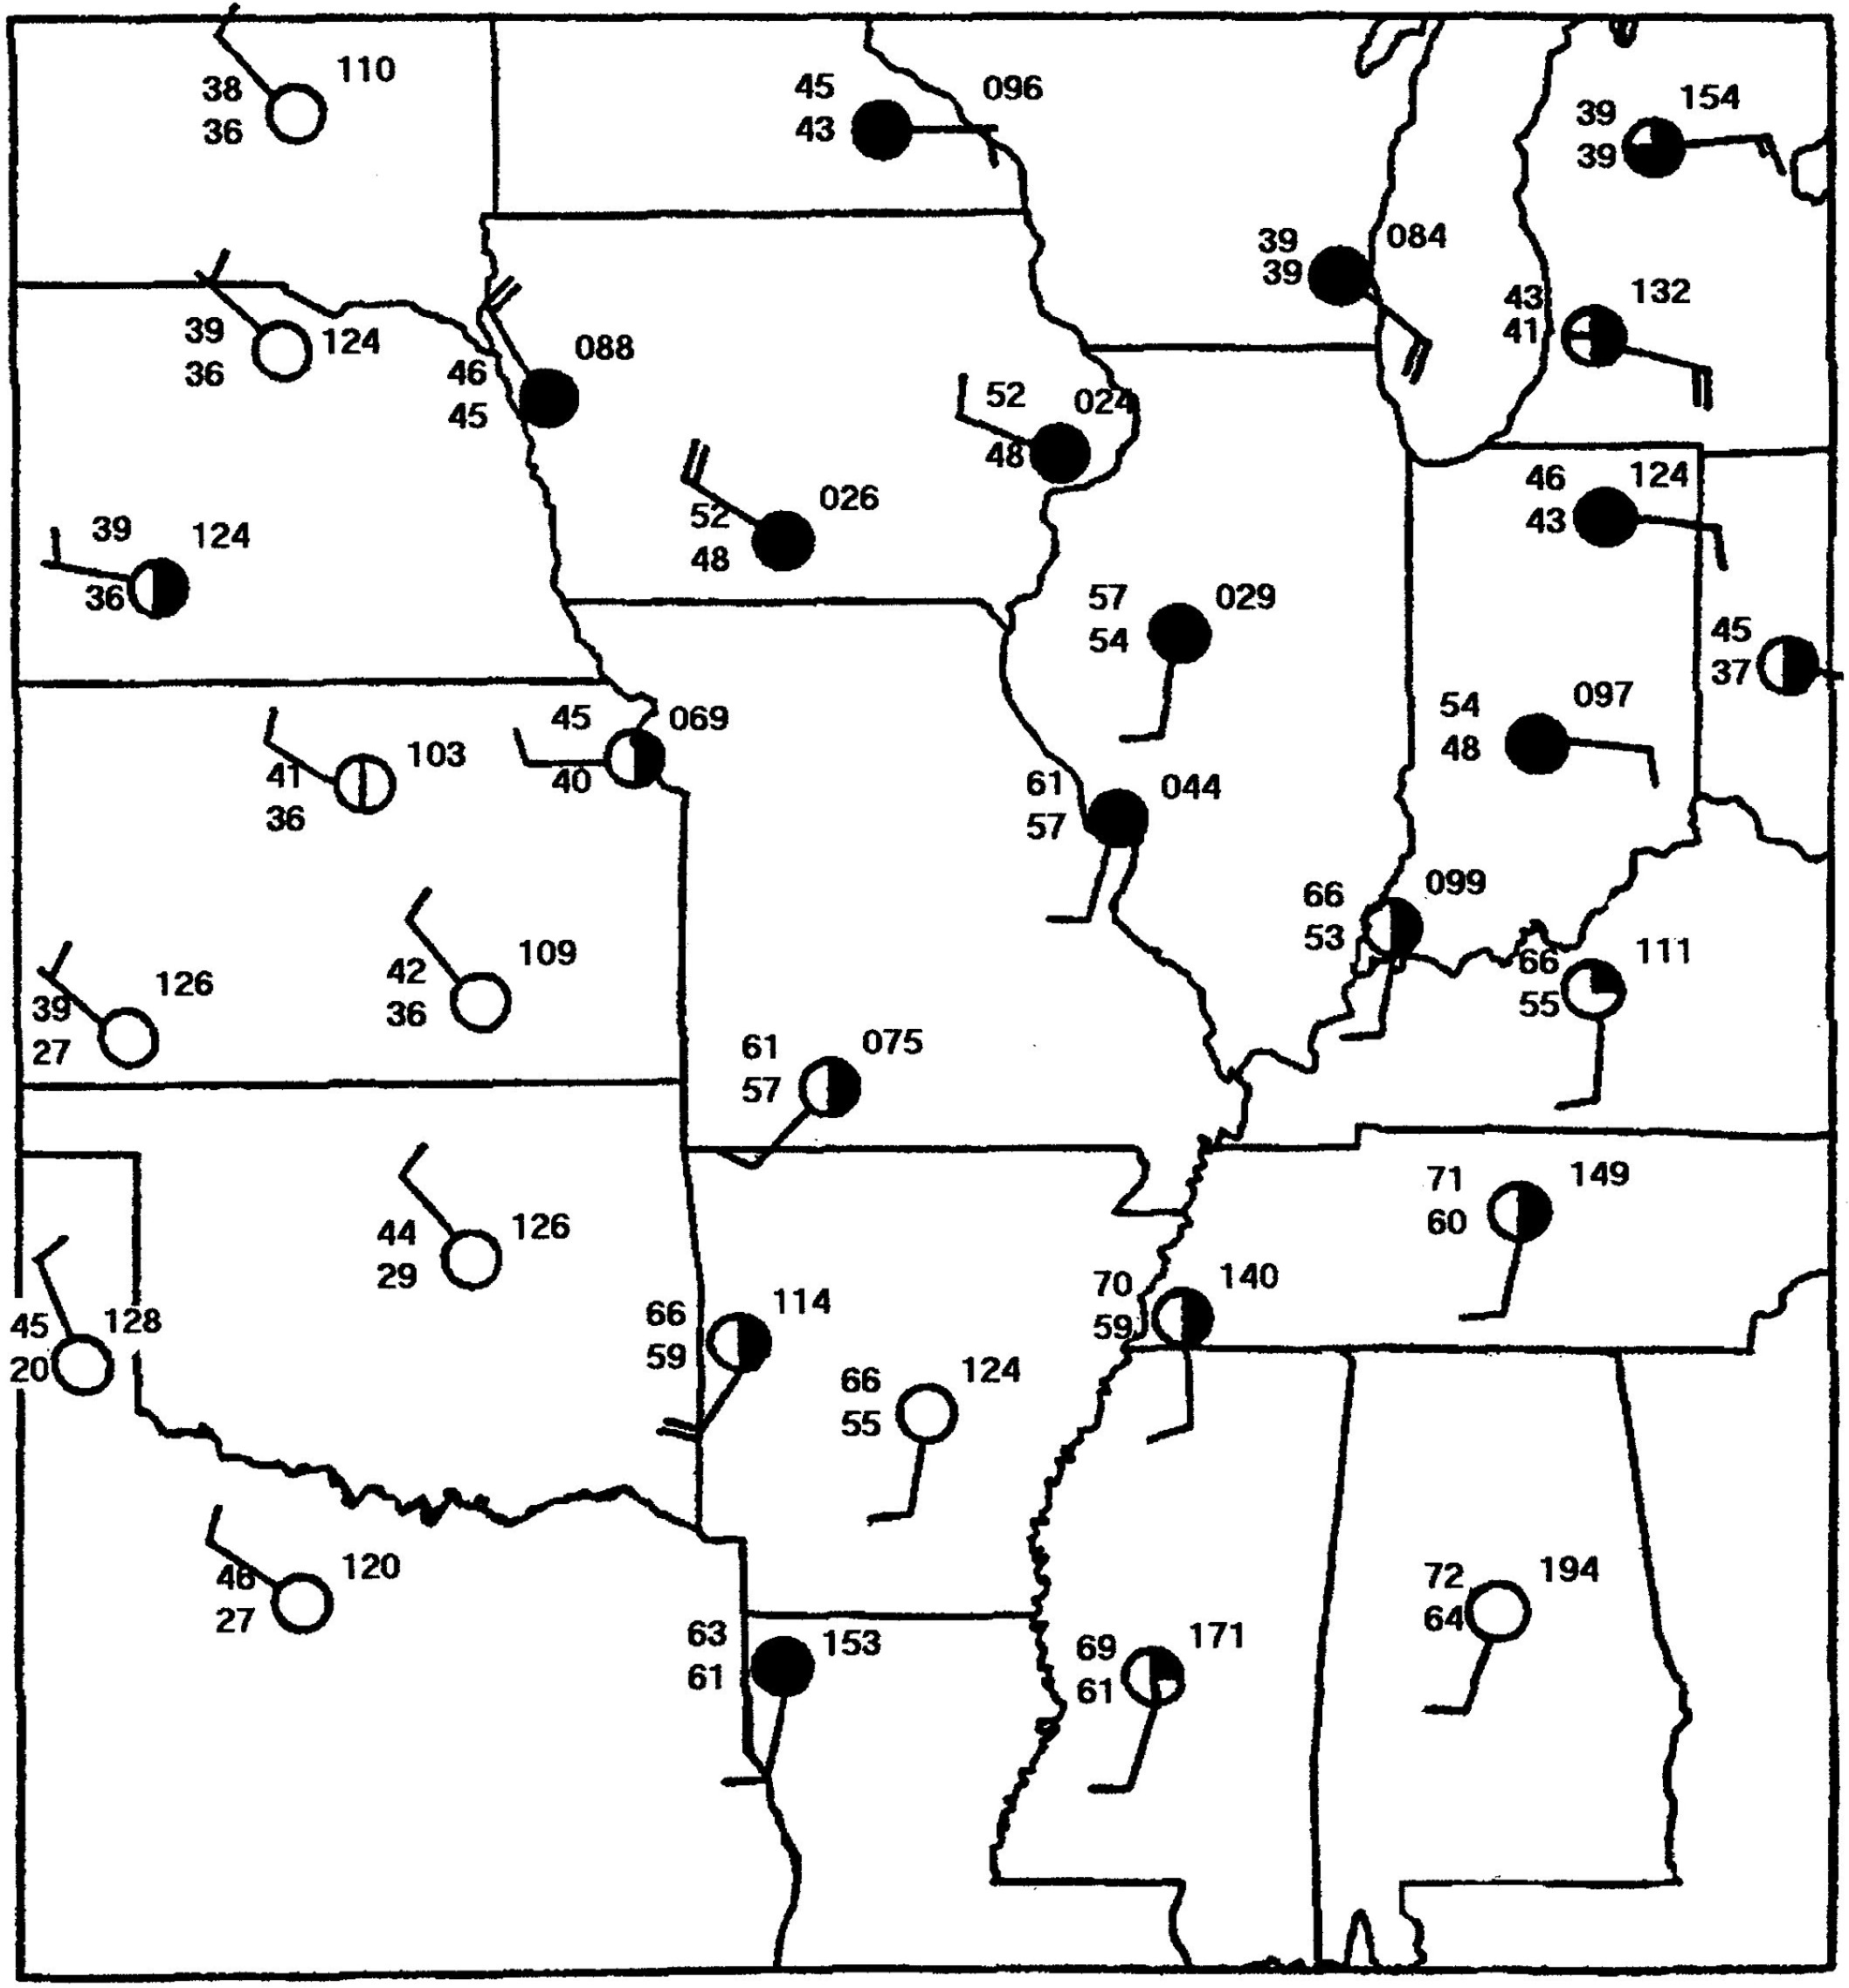

2. WEATHER MAP PLOTTING/ANALYSIS

From the main Lesson 3 page, click on background and then Contouring I. Read the page. Then return to the Background page and click on Contouring II. Read the page. Then go back to the main Lesson 3 page and click on Practice, and then Contouring Practice. Read and follow the directions. Do Lessons 1-5. When you finish that, go back to the main Lesson 3 page, click on Assignments, then contouring II, and try the analysis. It’s more difficult, and you’re on your own- no solution given!

Then draw the isobars on the 6 plots on pages 5-11 and turn them in.

1. Plot the 1032, 1036, 1040, and 1044 mb isobars on the map below. Label the isobars.
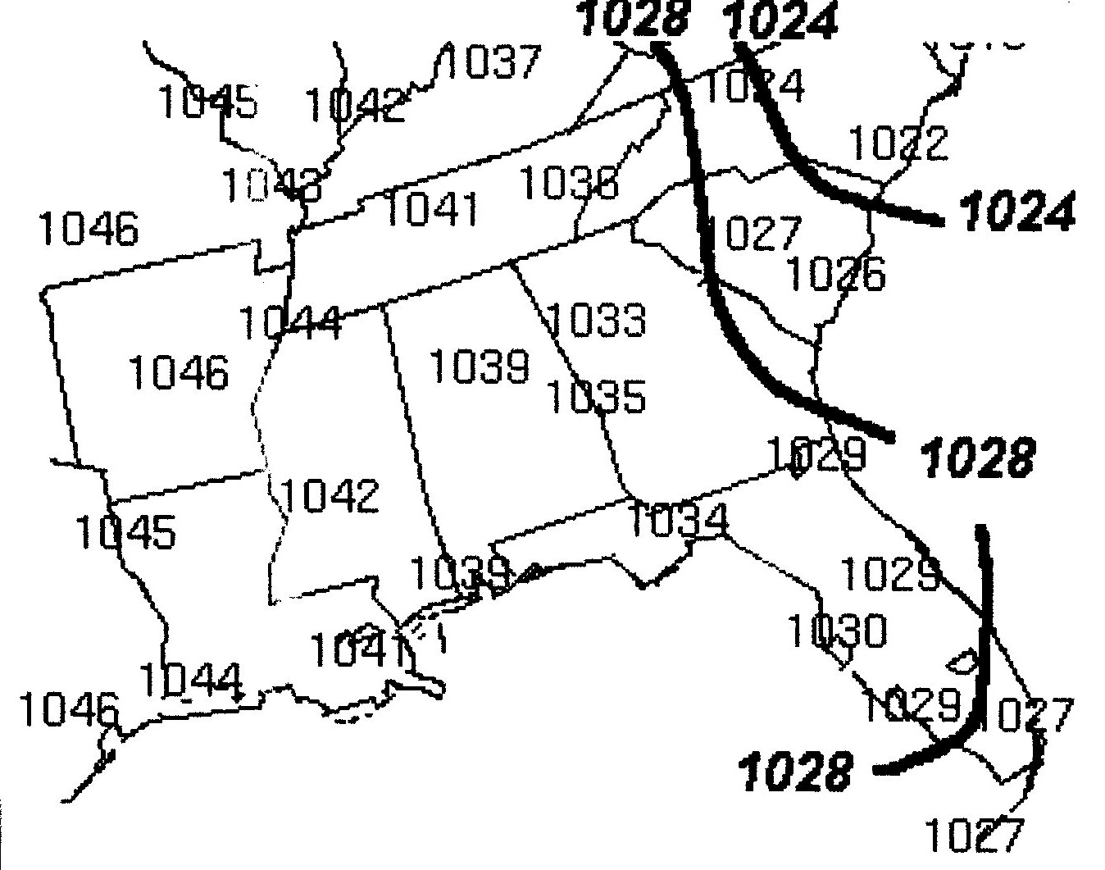

2. Draw isobars at 4 mb intervals on the map below. Start by completing the 1020 and 1016 mb isobars, which are already partially drawn. Then add the 1012 and 1008 mb isobars as well as the 1028 mb isobars in the upper right. Label the isobars.
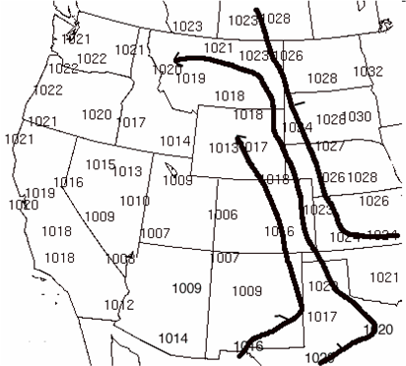

3. Draw the 1024, 1020, 1016, 1012, and 1008 mb isobars on the map below. Start with the 1024 mb isobar at the highlighted number over Salt Lake city, UT. Label your isobars.

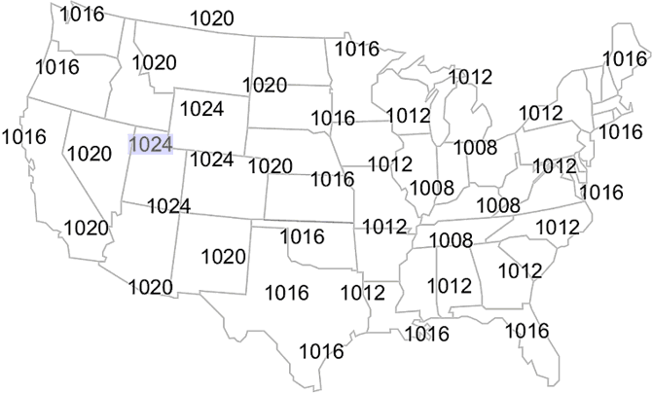
4. Circle areas of winds blowing in the same directions around the area of surface low pressure in the map below. Also pay attention to temperatures behind the cold and warm fronts and ahead of the warm front.

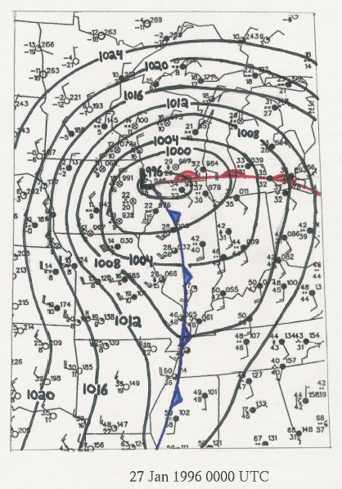

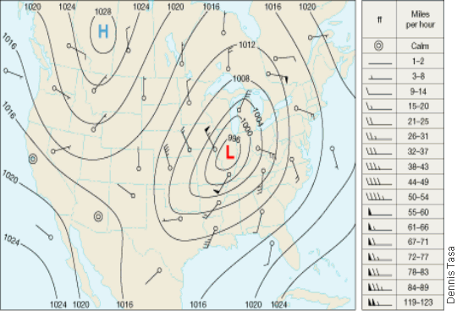
5. Circle areas of winds blowing in the same directions around the area of surface low pressure in the map below. Then draw a cold front and warm front that meet in the low.
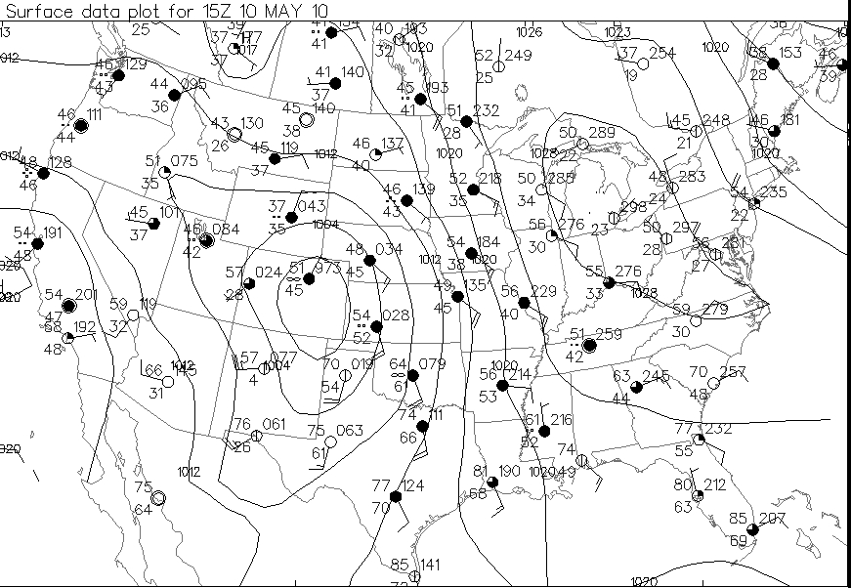
6. Circle areas of winds blowing in the same directions around the area of surface low pressure in the map below. Then draw a cold front and warm front that meet in the low.
7. Draw the 1000, 1004, 1008 and 1012 mb isobars on the data below and draw the Cold and Warm fronts. Label the isobars.
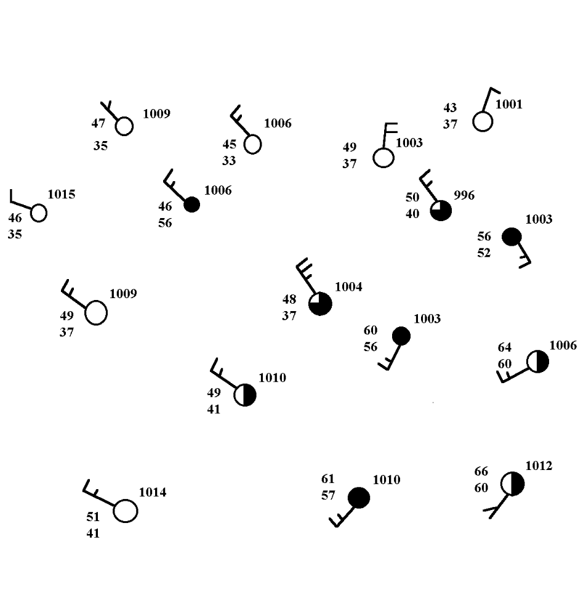

8. Draw isobars at 4 mb intervals (1000, 1004, 1008, 1012, and 1016 mb) on the map below. YOU HAVE TO ADJUST THE PRESSURE VALUES. Label the isobars. Label the Low Pressure area with a red “L”. Draw the cold and warm fronts.
9. Draw the 1000, 1004, and 1008 mb isobars and Cold and Warm fronts on the map below. You will need to convert pressure again. Note that some of the pressure values start with “9”s in the upper center of the map. For example, in Western Minnesota there is a pressure that is 974. If you add 10 to this, you get 1097.4 mb. Does this seem reasonable? No! 974 is actually a pressure below 1000 mb, so you just add a 9 to the beginning, not 10, and get 997.4 mb, the correct value.



